Spiti Valley Expedition



**Departure date : 1/04/2024**

**Return date:7/04/2024**

**Tour Guide: Yashas E sankol**

**Contact :** [**Yashase@bnmit.in**](mailto:Yashase@bnmit.in)

**Vehicle : Mahindra THAR**

:

Embark on an unforgettable journey through the rugged terrain and breathtaking landscapes of the Spiti Valley..Prepare to be mesmerized by ancient monasteries, pristine lakes, and snow-capped peaks as you explore some of the most untouched and remote locations in the region.

**Day 1: SHIMLA Arrival**

- Arrive in SHimla, known as the "Queen of Hills"

- Explore the local markets and indulge in some delicious Himachali cuisine

- Overnight stay in Shimla.

**Day 2: Shimla to Palampur**

- Depart for Palampur, a scenic hill station nestled amidst tea gardens

- Visit the Baijnath Temple, dedicated to Lord Shiva

- Enjoy a leisurely stroll along the Neugal Khad, a picturesque stream

- Overnight stay in Palampur

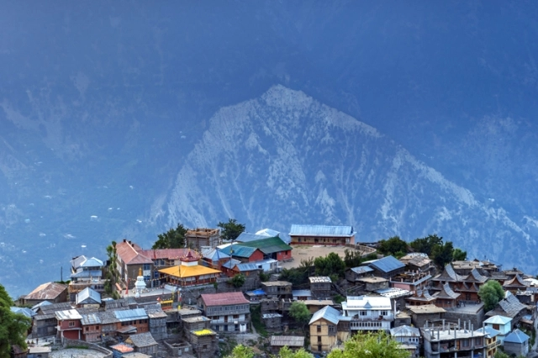

**Day 3: Palampur to Nohan**

- Travel to Nohan, a hidden gem offering tranquility and breathtaking views

- Explore the lush green landscapes and terraced fields

- Visit the ancient temples and interact with the welcoming locals

- Overnight stay in Nohan

**Day 4: Nohan to Chini**

- Journey to Chini, a quaint village untouched by commercialization

- Explore the rustic charm of the village and its traditional way of life

- Take a guided tour of the local farms and learn about agricultural practices

- Overnight stay in Chini

**Day 5: Chini to Key Monastery**

- Head towards the iconic Key Monastery, one of the largest monasteries in Spiti

- En route, stop at picturesque viewpoints to soak in the breathtaking scenery

- Explore the monastery complex and witness the monks' daily rituals

- Overnight stay near Key Monastery

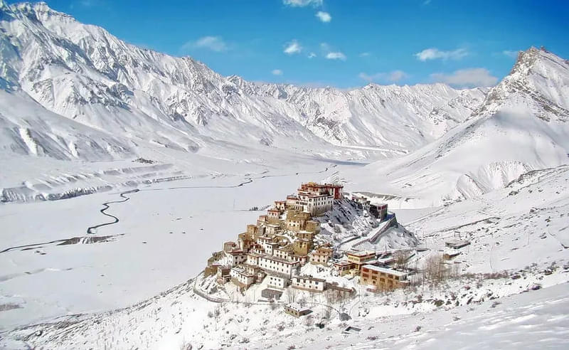

**Day 6: Key Monastery to Chandratal Lake**

- Depart for Chandratal Lake, a jewel of the Himalayas

- Trek to the lake's edge and marvel at its crystal-clear waters reflecting the surrounding peaks

- Set up camp near the lake and enjoy a night under the starlit sky

- Overnight stay in tents near Chandratal Lake

**Day 7: Chandratal Lake to Solan**

- Bid farewell to the enchanting landscapes of Spiti Valley

- Drive back to solan, stopping at scenic spots along the way

- Conclude the expedition with memories of a lifetime

Experience the allure of Spiti Valley like never before on this immersive 7-day expedition, where each day unfolds new adventures and discoveries amidst the majestic Himalayan scenery.

